A Guide to using the Cascadia Motion CM200DX inverter for Pre-charge

Quick summary of what the inverter expects
- The CM200DX requires an external pre-charge circuit (resistor + pre-charge relay + small fuse in parallel with the main contactor). See Hardware manual §3.3.3 and typical wiring Figure 4.
- The inverter can drive the pre-charge relay coil directly from its RLY1 high-side output (pin L1), and the main contactor coil from RLY2 (pin L2). RLY1/RLY2 are Hi-Side Drivers: continuous 1 A, surge 5 A; outputs referenced to KL30_BATT.
- The inverter’s internal DC bus capacitance (CM200DX ≈ 650 µF) must be charged through the pre-charge resistor. Manual gives a sizing example and timing (≈3 time constants before main contactor closes).

Recommended external components (from the hardware manual)
For the CM200DX BorgWarner / Cascadia lists the following parts (use these as direct references or spec guides):
- Pre-charge Relay: 30 A, 12 V coil, p/n 77-0026.
- Pre-charge Resistor: 600 Ω, 50 W (wire-wound recommended), p/n 53-0006.
- Pre-charge Fuse: 5 A, 500 V (recommended for pre-charge circuit), p/n G1-0013-01.
- Main contactor (example used successfully): Sensata / Gigavac GX14BA (BorgWarner p/n 77-0035). Must be DC-rated.
(Alternate device families are mentioned as examples — the manual suggests Sensata Gigavac P105 for HV relay/resistor branch and GX16/GX14 series for main contactor).

How to size the resistor & timing (worked example from manual)
- CM200DX DC link capacitance ≈ 650 µF.
- Example: 320 V battery, choose 600 Ω resistor → initial current = V/R = 320/600 ≈ 0.533 A. Power dissipation at t=0 = V²/R = 320²/600 ≈ 171 W (short term). Manual notes a 600 Ω, 50 W wire-wound resistor can typically tolerate the short pulse but check surge rating; they chose 600 Ω/50 W as typical for DX. It takes roughly 3 time constants to charge (τ = R·C): τ = 600 Ω × 650e-6 F = 0.39 s → 3τ ≈ 1.17 s (so main contactor should close after ~1.17 s).
- Rule of thumb from manual: size resistor to charge capacitors quickly but so it will survive a fault (i.e., resistor must tolerate the surge energy). Use manufacturer surge specs; wire-wound resistors are normally recommended.

Wiring topology & placement (what the manual shows)
- Wiring topology: battery (+) → main fuse → branch that contains (a) pre-charge relay + resistor in series (then to inverter DC+), and (b) main contactor in parallel with that branch. See Figure 4 (Pre-charge Circuit Wiring) in hardware manual. The pre-charge branch is normally used to charge the inverter DC bus, and after the inverter indicates the bus is at the correct voltage, the main contactor is closed (bypassing the resistor).
- Suggested placement: put the pre-charge circuit after the main fuse so that if the main fuse blows the pre-charge is disabled (manual recommends this arrangement).
- Pre-charge coil wiring: use inverter pin L1 (RLY1) to drive the pre-charge relay coil (12 V from KL30_BATT). Use L2 (RLY2) to drive the main contactor coil. If you need more coil current than the Hi-Side Driver can supply, use an intermediate automotive relay or a separate 12 V relay coil powered from KL30_BATT and switched by a small transistor/relay that RLY1 can drive. Remember HSD continuous current rating is 1 A (surge 5 A).

Step-by-step hardware setup (safe, checklist style)
- Select components using the manual suggestions as baseline: 600 Ω 50 W resistor, pre-charge relay p/n 77-0026 (or equivalent HV relay able to carry the pre-charge current and rated for the system voltage), pre-charge fuse 5 A/500 V (or equivalent).
- Wire HV path per Figure 4: battery + → main fuse → node → (a) pre-charge relay (series) → resistor → inverter DC+; (b) main contactor → inverter DC+. Battery negative to inverter DC−. Ensure good HV connectors (CM200 uses Rosenberger HPK family).
- Wire relay coils: connect pre-charge relay coil to inverter pin L1 (RLY1) and to KL31_GND return. Connect main contactor coil to L2 (RLY2). Ensure KL30_BATT is tied to 12 V supply and KL31_GND is correct. If coil current >1 A, use an intermediate relay coil (RLY1 → small relay coil → HV pre-charge relay coil), or use external 12 V power.
- Fuse the pre-charge wiring: put the small pre-charge fuse (example 5 A/500 V) in series with the pre-charge branch (manual recommends ~5 A for the pre-charge wiring / 18 AWG). Use correct HV fuse type (semiconductor fuses recommended for main fuse; pre-charge fuse can be a small high-voltage fuse compatible with voltage).
- Choose resistor type: wire-wound power resistor with adequate surge rating (manual suggests a 50 W wire-wound for 600 Ω but check manufacturer surge tolerance). Mount resistor in ventilated area and allow for burst heat.
- Confirm control wiring for low voltage: KL30_BATT permanently tied to battery + (<1 mA draw), KL15 to switched 12 V for communications, KL15_EN to allow PWM enable; ensure KL31_GND present. These low-voltage pins supply the inverter logic and the relay drivers; missing 12 V will prevent RLY outputs.

Software/firmware configuration & commissioning
- The software VSM has explicit Pre-Charge states (Pre-charge init/state/complete). If the inverter’s pre-charge is enabled it will attempt the pre-charge sequence automatically on HV application; the pre-charge relay will remain closed for ~3 seconds (if you use built-in pre-charge). If pre-charge doesn’t complete in that time the inverter will fault and open the pre-charge relay. Check Software manual section “Pre-Charge Sequence” / VSM_State for details.
- EEPROM parameter to check: Precharge_Bypassed_EEPROM — set to 0 to enable pre-charge sequence (default 0). Setting to 1 bypasses pre-charge (not recommended during commissioning). See Software manual Appendix A.2 (System Configuration Parameters) for the parameter address and meaning.
- Commissioning checks (software & GUI):
  - Power the inverter LV (KL30_BATT) with HV not connected. Connect RMS/CAN/serial and verify the inverter boots and you can read the VSM state.
0A-0162-03_HW_User_Manual
  - Apply HV (with pre-charge circuit wired) and watch the inverter go through the pre-charge states — check V_DC_Filtered or GUI parameter that reports Vdc. After pre-charge completes the inverter will assert OK (RLY3) and then assert the main contactor (RLY2).
  - If the pre-charge times out, the inverter will fault; review wiring/resistor/fuse and measure DC bus voltage during pre-charge attempt.

Practical suggestions / safety notes (from the manual + best practice)
- Do not use AC-only contactors/relays for the main contactor. Use DC-rated contactors (polarity sensitive). Check contactor datasheet for DC making/breaking capacity. Manual gives Gigavac GX14BA as an example.
- Resistor energy/surge rating: even though a 50 W resistor is listed for 600 Ω in the manual, verify the pulse / surge rating with the resistor manufacturer because initial dissipation is high (171 W in example). Consider a higher continuous wattage part or resistor with explicit pulse rating if your installation will see many cycles.
- Wire gauge: pre-charge current is typically small (~0.5 A in example) so small wire (recommended 18 AWG) is ok for the pre-charge branch; main HV wires must be sized for maximum inverter current using appropriate cable and connectors.
- Fusing: main DC input must be fused and rated for battery voltage and maximum short-circuit current; semiconductor fuses are recommended for main fuse. The pre-charge branch should have a small HV fuse (~5 A) sized to protect the small wires used.
- Hi-Side Driver limits: RLY1/RLY2 have continuous 1 A and surge 5 A drive capability. If you plan to drive a heavy coil directly from RLY1/RLY2 ensure coil inrush ≤ 5 A and steady coil ≤ 1 A, or else use an intermediate relay powered from KL30_BATT and driven by RLY1 (i.e., RLY1 switches a small relay or transistor).
- Passive discharge: CM200DX has a passive discharge resistor inside (70 kΩ) that discharges the DC bus slowly — see table for 3τ (≈137 s for CM200DX). Do not touch HV terminals until you verify safe voltage. Manual warns to wait if unsure.
0A-0162-03_HW_User_Manual

Minimal commissioning procedure (practical)
- With LV connected (KL30_BATT, KL31_GND), confirm inverter powers up and you can talk to it via RMS/CAN. (Low-voltage setup steps: Quick Start Guide).
- Ensure Precharge_Bypassed_EEPROM = 0 (pre-charge enabled).
- Verify pre-charge branch wiring, resistor, pre-charge fuse, main fuse, main contactor wiring per Figure 4.
- Apply HV. Watch the inverter VSM pre-charge states in the GUI (Pre-Charge Init → Pre-Charge Active → Pre-Charge Complete). Confirm DC bus voltage rises toward battery voltage during pre-charge and that the main contactor closes only after pre-charge completes. If pre-charge fails check resistor, fuse, coils, and that RLY1 is energising.

- If you need to test manually, you may temporarily bypass pre-charge in a safe test bench using Precharge_Bypassed_EEPROM=1, but only do that on a bench with appropriate series current limiting — do not do that in a vehicle or with main battery connected without HV protection.

Exact places in your PDFs to cross-check (section references and file citations)
- Hardware manual — Pre-Charge Circuit and wiring figure (look for: §3.3.3 "Pre-Charge Circuit" and §4.2 "Pre-charge Circuit Wiring", also Figure 4): see hardware manual.

- Hardware manual — BorgWarner part numbers and sizing example (600 Ω / 50 W, 5 A fuse, pre-charge relay p/n 77-0026): see the parts table & sizing text.

- Hardware manual — RLY pin descriptions & HSD/LSD driver limits (RLY1 pre-charge drive, RLY2 main drive; Hi-Side driver current limits): see I/O connector pin map and digital outputs section.
0A-0162-03_HW_User_Manual

- Software manual — Pre-Charge Sequence (VSM states) and EEPROM param Precharge_Bypassed_EEPROM: see "Vehicle State Machine → Pre-Charge Sequence" and Appendix A system parameters.

Short checklist you can copy into a build log
- Install main fuse (semiconductor type) rated for battery voltage & pack short-circuit current.
- Install pre-charge resistor (600 Ω recommended for CM200DX) in ventilated location; check pulse rating.
- Install pre-charge relay (30 A coil rated) and small HV fuse (5 A/500 V) in pre-charge branch.
- Wire relay coils to inverter RLY1 (pre-charge) and RLY2 (main); check coil current vs HSD limits; add intermediate relay if required.
- Confirm KL30_BATT, KL15, KL15_EN, KL31_GND wiring for LV.
- LV power up → check RMS/CAN comms → set Precharge_Bypassed_EEPROM=0 → apply HV → observe pre-charge sequence via GUI.

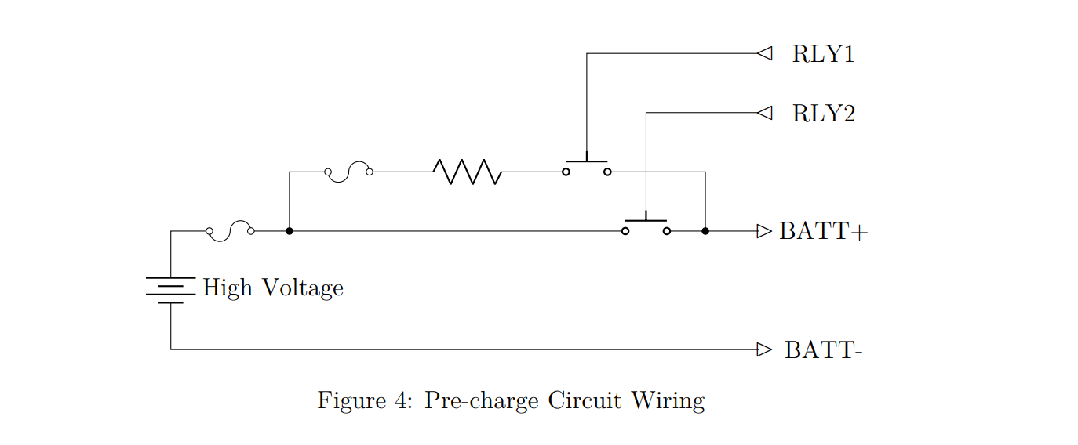
Appendix

